SCENARIO
You are an electrical technician in a company producing various electronic printed circuits for domestic applicant (TV, Radio, Heaters…etc.) as attenuators, amplifier, tuners…etc., you are required to apply two port network models and use your knowledge about signal analysis including composite signals and the calculation of the circuit response in case of step input.

To achieve the assessment criteria for pass (P3.1) you must answer the following task

Task 1:
- A complex voltage is presented by:
V = (30 sin $ωt$ + 20 sin 2$ωt$ )
Determine:
- Rms value.
- Mean value.
- A complex voltage and current are given by:
V = (30 sin $ωt$ + 20 sin 2$ωt$ )
i = (0.2 sin $(ωt-30)$ + 0.1 sin $(2ωt-50)$ )
Determine:
- The total active power supplied to the circuit.
- Overall power factor

To achieve the assessment criteria for pass (P3.2)(Part 2/2) you must answer the following task

Task 2:
- Analyze the complex periodic wave according to the values of voltages that corresponding to the angles shown in table (1) [Solve only for DC and first harmonic sin and cos]

Table (1)

- Without performing calculations state which components will be present (i.e. dc , sin , cos) in the waveform shown in fig (1)
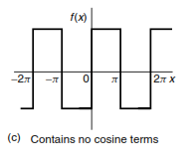
(a)
(b)
Fig (1)
To achieve the assessment criteria for pass (P4.1)(Part2/2) you must answer the following task
Task 3:
Use Laplace transforms for the transient analysis of the network shown in figure (2)
Note:
- Transient analysis (find i(t) , Vc(t))
- You can use the Laplace Transform table (2).
R
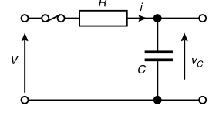
Fig (2)
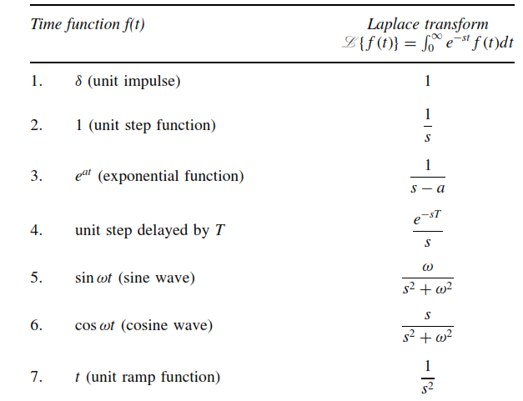
Table (2)

